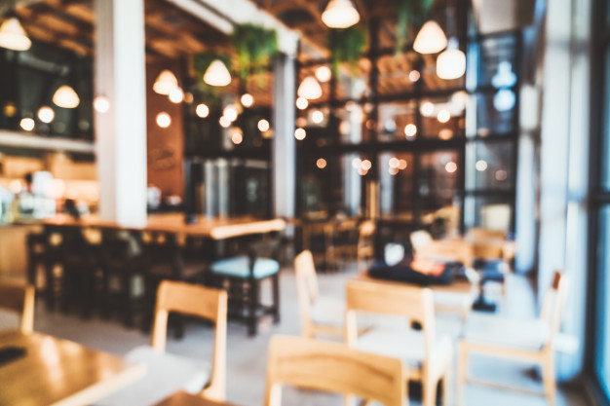

Restaurants in Famous Indian Cities

Riona Almeida | Applied Data Science Capstone Project (IBM/Coursera)

29th April, 2020

**Content**

* A description of the problem and a discussion of the background.
* A description of the data and how it will be used to solve the problem.

# 1.1 Background

Being a citizen of India, I have always been intrigued with what the various cities of India has to offer. With our wide range of cuisines and our very large appetite to try different delicacies, restaurants and cafés around this country are not only well versed in serving Indian cuisine but are highly recommended for international dishes too.

It is not an uncommon fact that there are some densely populated cities dispersed around Indian soil. Financial superpowers like Mumbai, technical giants like Bangalore and emerging cities like Pune – each have their own ___. Then again there are some religious and historic sites like ____ that have managed to uphold their legacies in terms of maintaining livelihoods. What each city has to offer to arouse our taste buds and how they are connected to each other? That is the question the natural foodie in me seeks to answer.

# 1.2 Problem

Clustering restaurants from different cities in India will help determine some common characteristics between them. Analyzing these different venues, we can visualize the following data:

* Groups of cities similar to each other w.r.t restaurants
* Why these places are so populated?
* What characteristics do they share?

# 1.3 Interest

Say if one were to visit a famous Indian city and would want to acquire knowledge of the best food spots. Or better still maybe some entrepreneur wants to set up base with a restaurant, he/she will need to know the kind of cuisines and eateries the general public picks. With the attained information from this study, these individuals will be able to make their stay and capital more profitable.

This data can also be useful for culinary experts and food critics to categorize and rate famous places based on their similarities.

# 2. Data Acquisition

For famous Indian cities, I found a dataset of 200 odd famous cities with respect to population. It has the following attributes:

* Latitude
* Longitude
* State
* Population
* City name

Source : <https://simplemaps.com/data/in-cities>

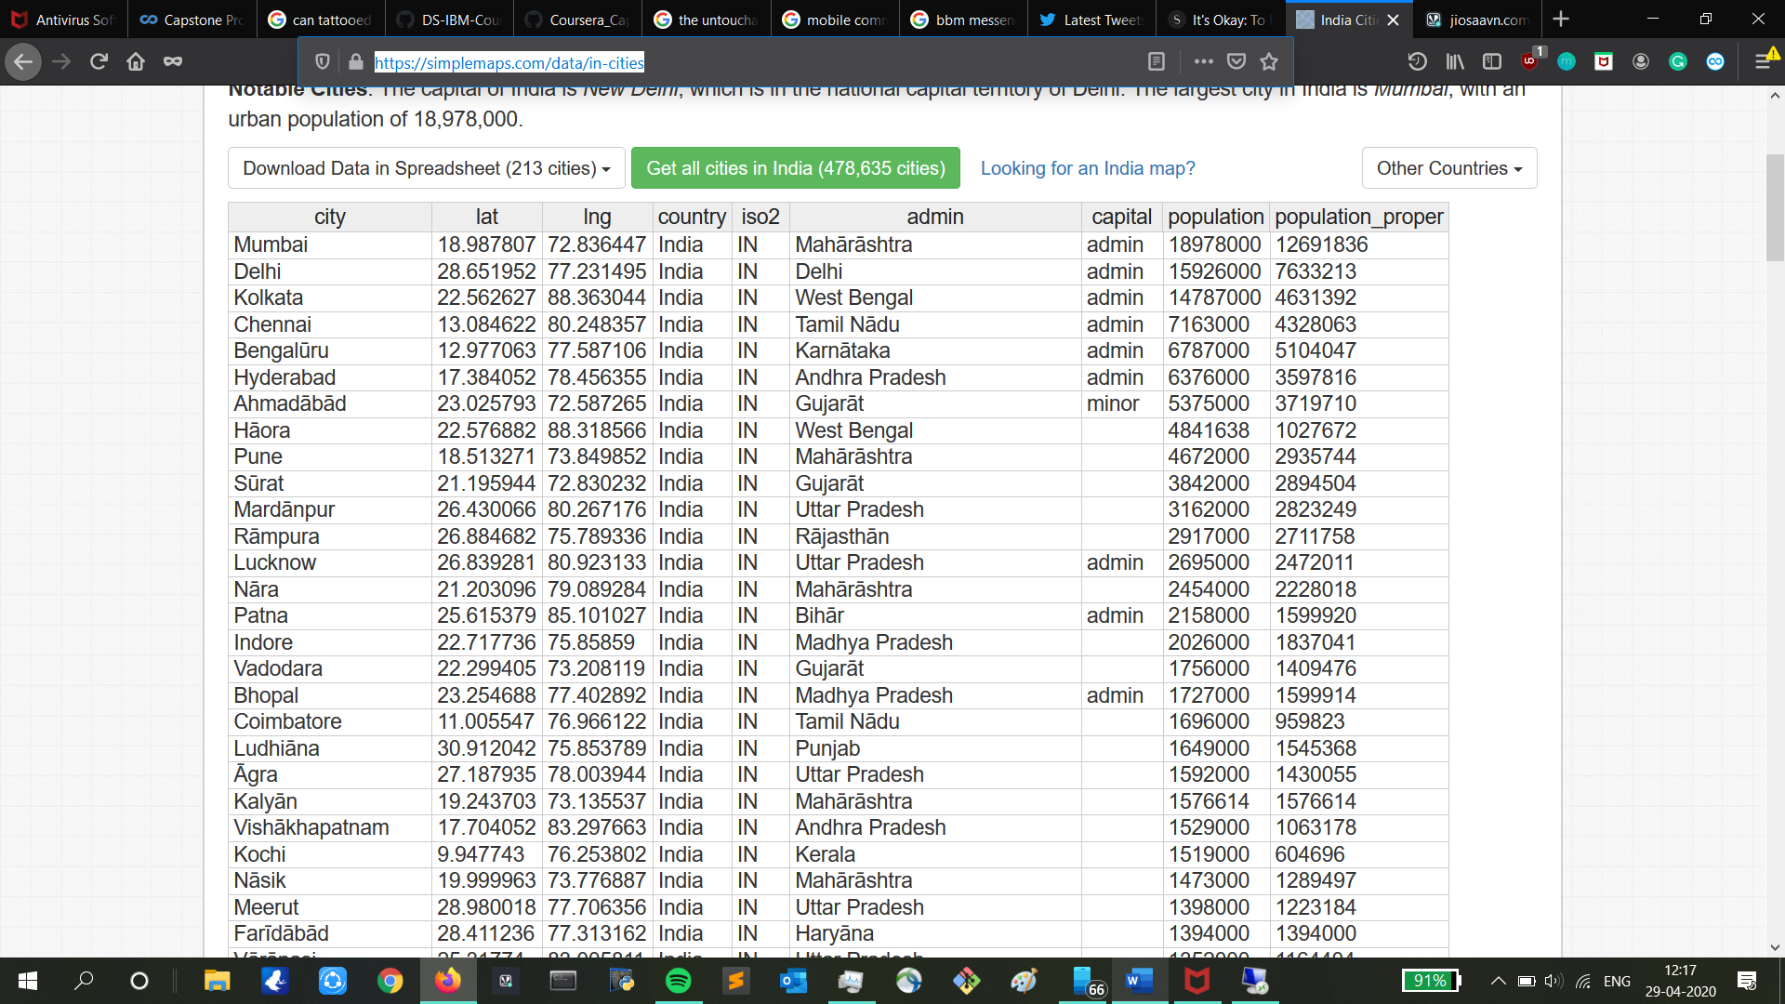

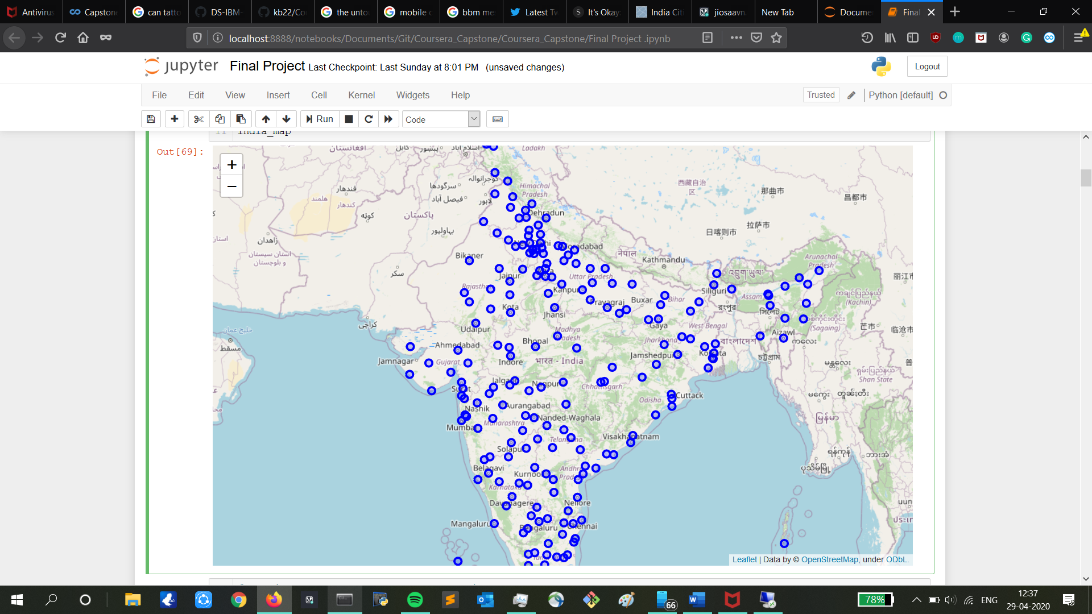

Now that we have the details of each city, the essential information i.e. the venue data can be extracted using the FourSquare API using request methods.

To get venues and their categories from these cities, I will use the FourSquare API. The latitude and longitude values can be retrieved from the above table. For each city the range will be around 5 km and limit of up to 100 most popular venues.

From the FourSquare API, the data retrieved will have the following attributes:

* Venue
* Venue Category
* Latitude
* Longitude

From this data, for analysis I will only require restaurants/ café/ hotels to determine a food roadmap of the country.